HOW TO INSTALL MONGODB MANUALLY

First create a Centos instance

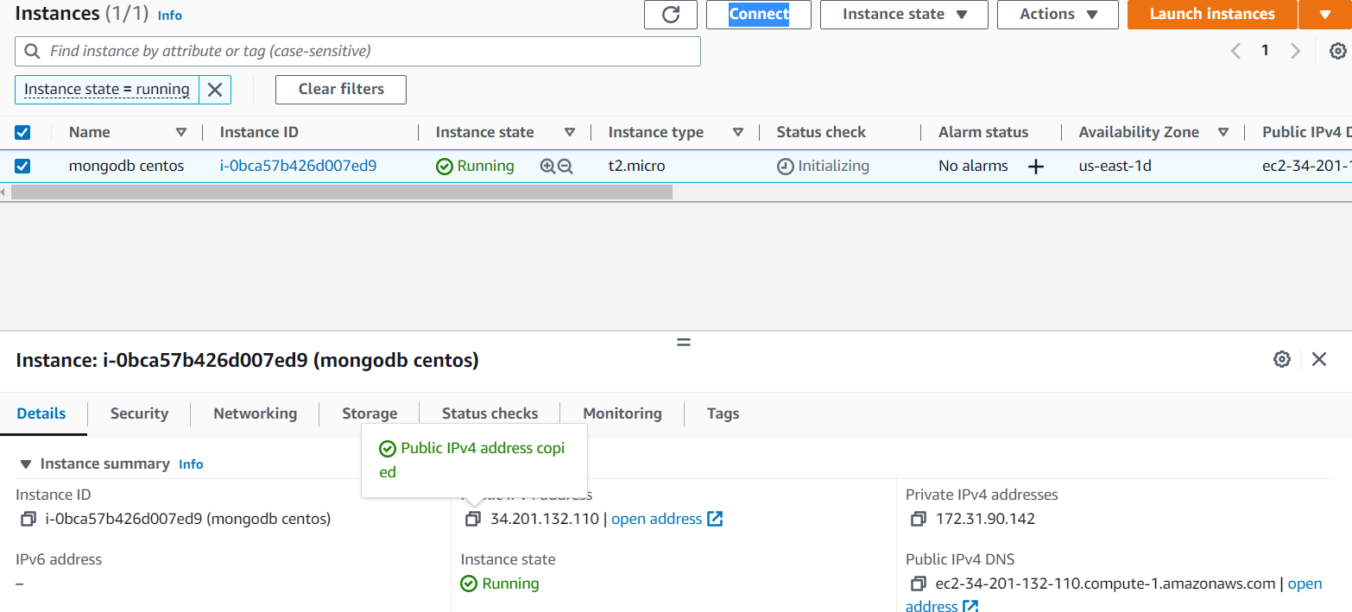

Create a file and add repositories

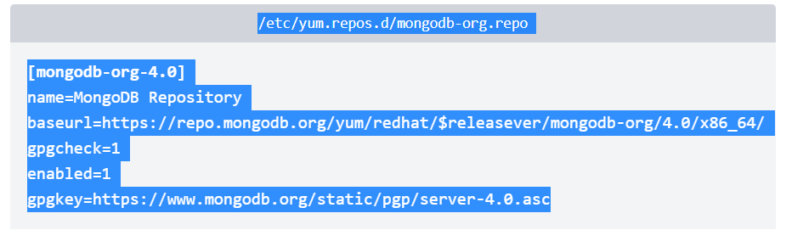

Install mongodb-org

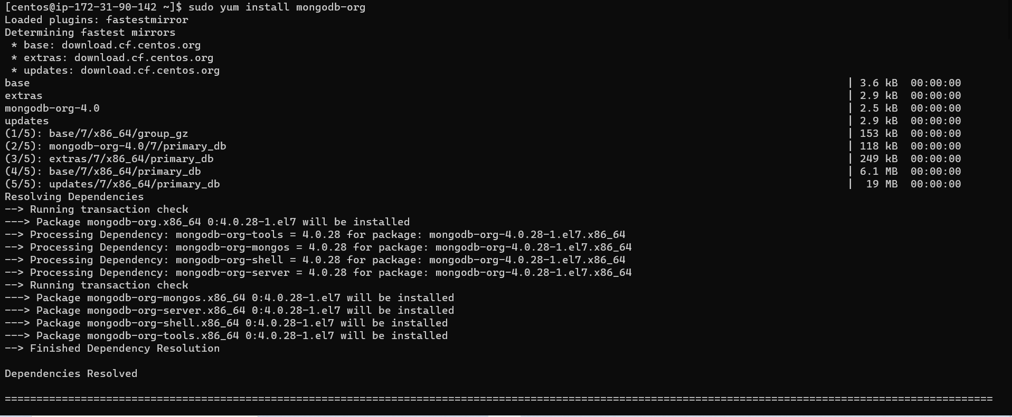

Then enable mongod

“sudo systemctl enable mongod”

And start mongod

“sudo systemctl start mongod”

Finally check status

